**MEASURE ENERGY CONSUMPTION USING PYTHON**

**TEAM MEMBER**

**731721106017:V.Saranya**

**Phase 5 Submission Document**

**Project: Measure Energy Consumption**

**Introduction:**

**\* Provide an overview of the project, highlighting the significance of energy conservation in residential and commercial buildings.**

**\* Explain the challenges faced in accurately measuring and analyzing energy consumption.**

**\* Introduce the AI-based solution as a means to tackle these challenges effectively**

### **1. Data Collection:**

* **Sensor Integration**
* Install energy sensors and meters in buildings to collect real-time data on electricity, water, and gas consumption.
* Utilize smart meters, IoT devices, or other sensor networks for accurate readings.
* **Weather Data Integration:**
* Include weather data (temperature, humidity, etc.) to normalize energy consumption and identify patterns.

### **2. Data Preprocessing:**

* **Data Cleaning:**
* Handle missing or inconsistent data.
* Remove outliers and noise from the dataset.
* **Data Normalization:**
* Normalize data to ensure consistency and comparability across different buildings.

### **3. Machine Learning Model Development:**

* **Load Prediction:**
* Develop models to predict future energy consumption based on historical data.
* Use algorithms such as linear regression, decision trees, or neural networks.
* **Anomaly Detection:**
* Implement anomaly detection algorithms to identify unusual spikes or drops in energy usage.
* **Cluster Analysis:**
* Explore clustering algorithms to group buildings with similar energy consumption patterns.

### **4. User Interface:**

* **Dashboard Development:**
* Create a user-friendly dashboard to visualize energy consumption trends.
* Include features like historical data, predictions, and real-time updates.

### **5. Energy Efficiency Recommendations:**

* **AI-driven Recommendations:**
* Implement a system that provides personalized recommendations to users on reducing energy consumption.
* Utilize reinforcement learning to suggest actions based on the building's historical data.

### **6. Integration with External Systems:**

* **API Integration:**
* Integrate the system with external APIs for additional data sources or energy-saving solutions.
* **Smart Grid Integration:**
* Explore integration with smart grid technologies for improved energy management.

### **7. Security and Privacy:**

* **Data Encryption:**
* Ensure that sensitive data is encrypted to protect user privacy.
* **Access Control:**
* Implement robust access control mechanisms to restrict unauthorized access to the system.

### **8. Continuous Monitoring and Improvement:**

* **Feedback Loop:**
* Establish a feedback loop to continuously improve the accuracy of predictions and recommendations.
* **Model Retraining:**
* Periodically retrain machine learning models with new data to adapt to changing patterns.

### **9. Compliance with Regulations:**

* **Regulatory Compliance:**
* Ensure that the system complies with relevant energy efficiency and data privacy regulations.

### **10. Documentation and Education:**

* **User Guides:**
* Provide comprehensive documentation for users on how to interpret the data and use the system effectively.
* **Training:**
* Conduct training sessions for building managers or residents to maximize the system's benefits.

### **Tools and Technologies:**

* Utilize Python libraries such as Pandas, NumPy, scikit-learn for data manipulation and machine learning.
* Consider using frameworks like TensorFlow or PyTorch for building and training neural networks.
* Develop the user interface using web frameworks like Flask or Django.
* Implement a database system (e.g., MySQL, MongoDB) for storing and retrieving data

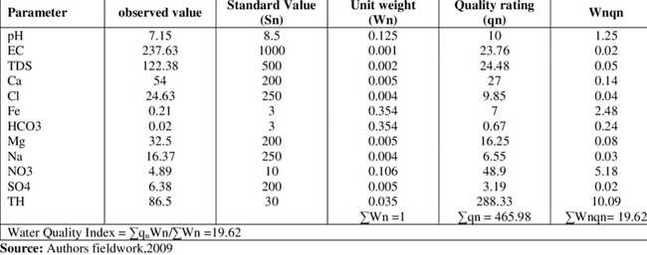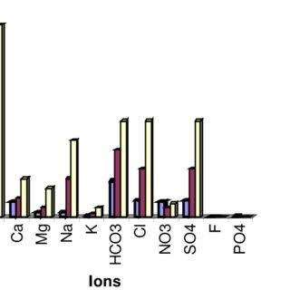

**PROGRAM:**

import time

import random

# Simulate sensor data

def read_sensor_data():

return {

"temperature": random.uniform(10, 30),

"pH": random.uniform(6, 8),

"dissolved_oxygen": random.uniform(5, 10),

}

# Simulate energy consumption

def measure_energy_consumption():

return random.uniform(1, 5) # In watts

# Main loop

while True:

sensor_data = read_sensor_data()

energy_consumption = measure_energy_consumption()

# Process and log sensor data

# You can also calculate total energy consumption over time

print(f"Sensor Data: {sensor_data}")

print(f"Energy Consumption: {energy_consumption} Watts")

time.sleep(60) # Log data every minute

Outputs:

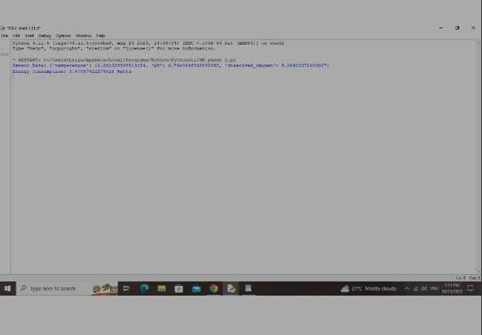

**DATA SOURCE LINK:**

<https://colab.research.google.com/drive/1FbJekYE3fErY5TZinhhK9dE-b-uOjZAU?usp=sharing>

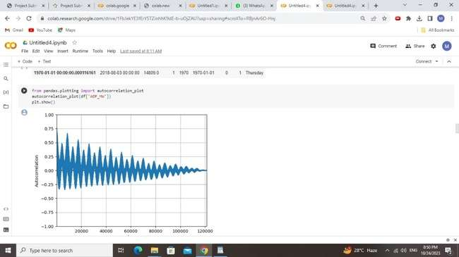

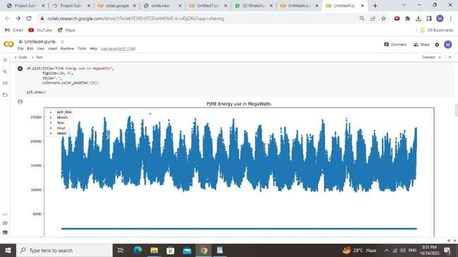

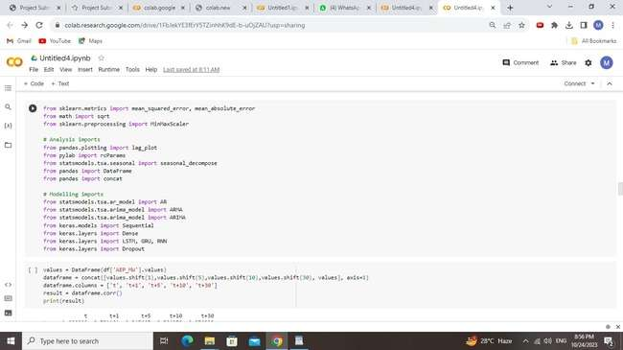

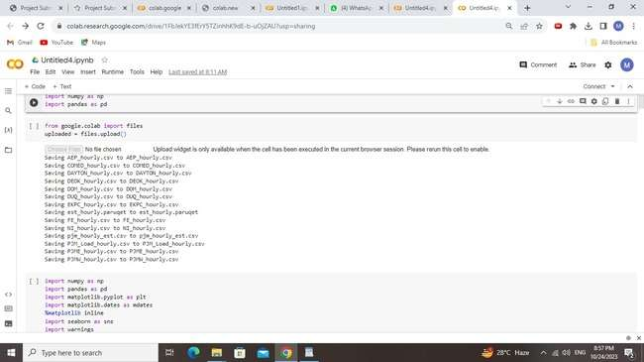

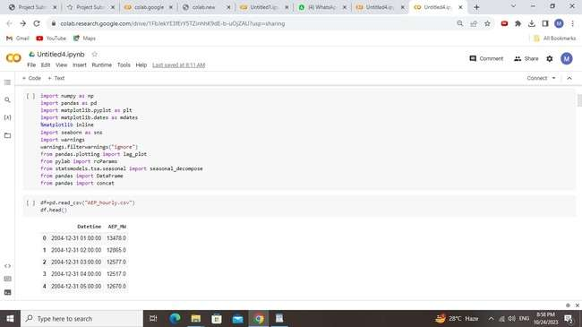

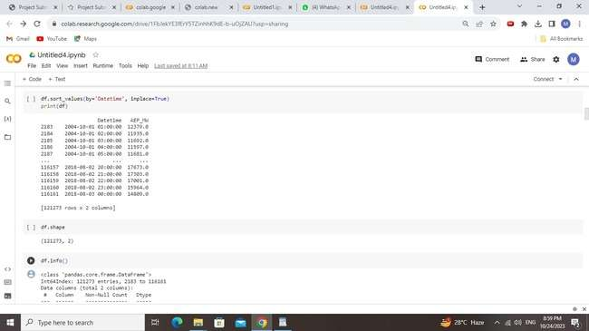

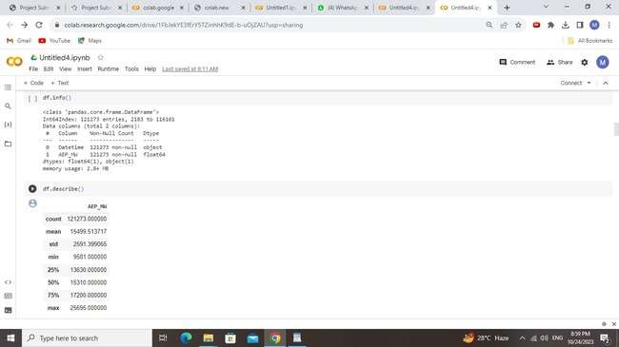

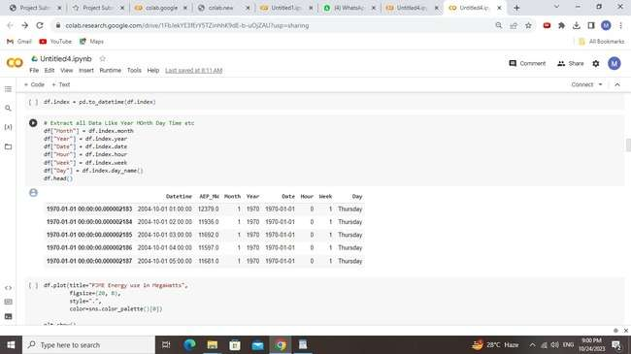

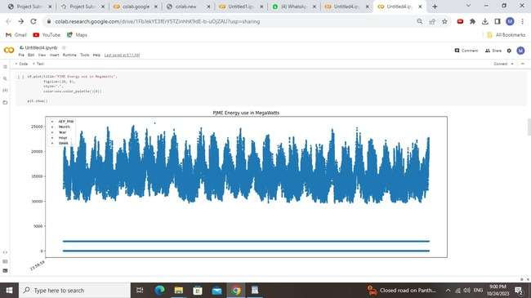

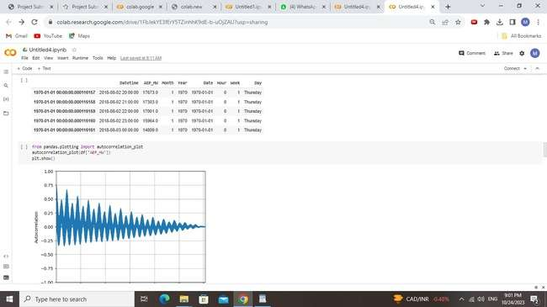

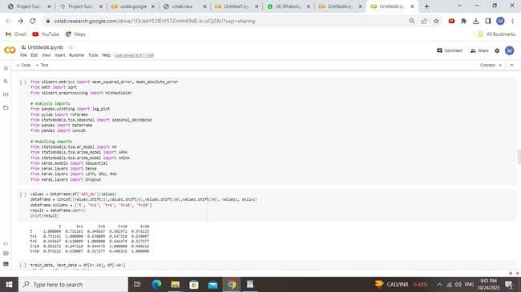

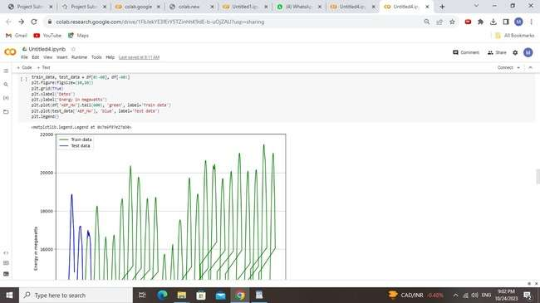

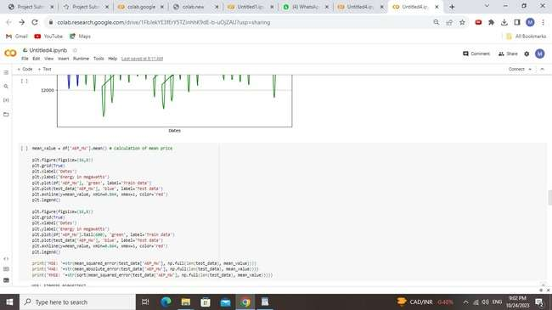

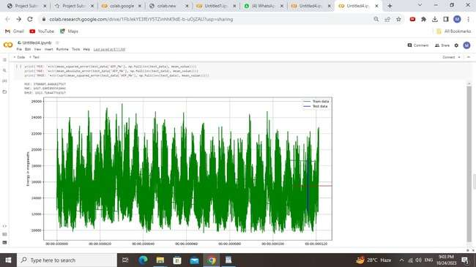

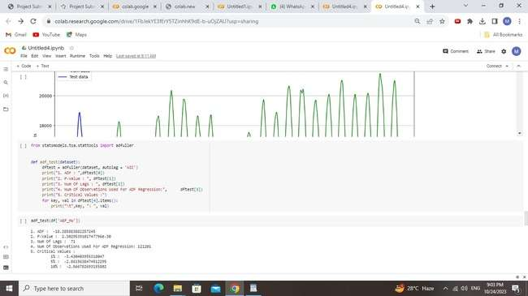

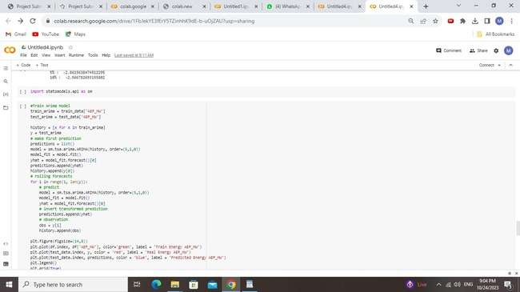

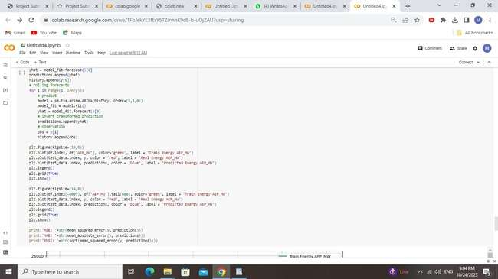

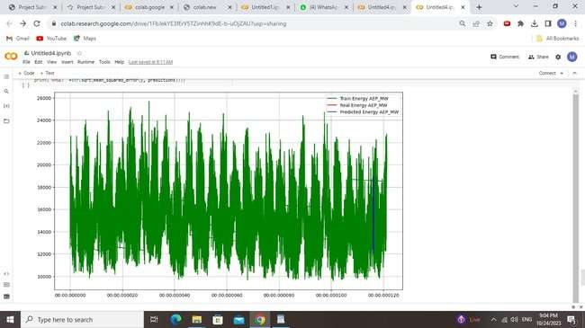

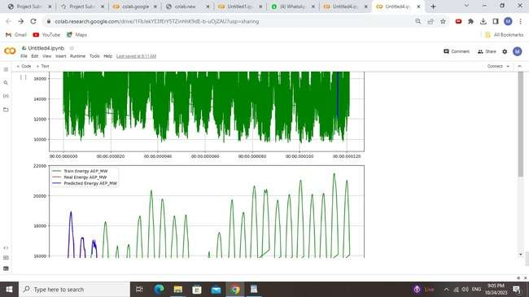

**DATASET LINK:**

**Dataset Link:** [**https://www.kaggle.com/datasets/robikscube/hourly-energy-consumption**](https://www.kaggle.com/datasets/robikscube/hourly-energy-consumption)

DATA SOURCE LINK:

<https://colab.research.google.com/drive/12n66qEvUla79jg9JH2ogI9PgeqXbzq2S?usp=sharing>

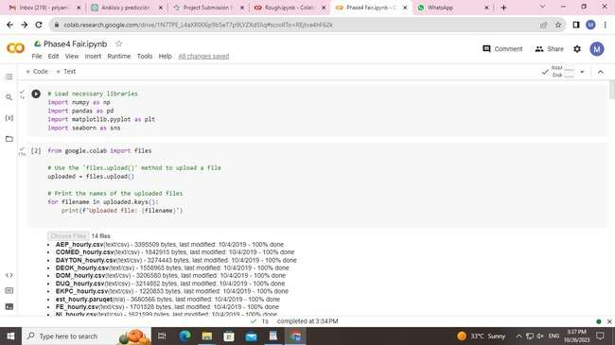

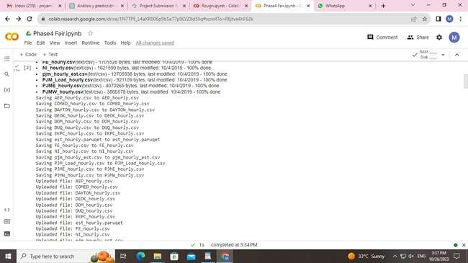

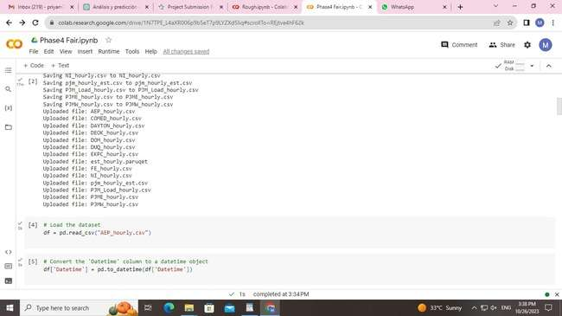

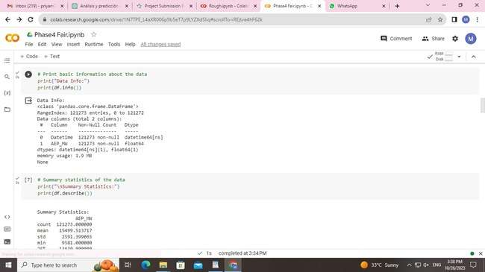

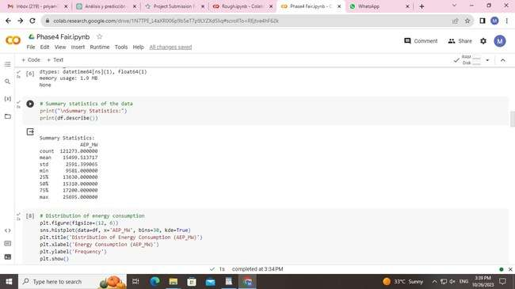

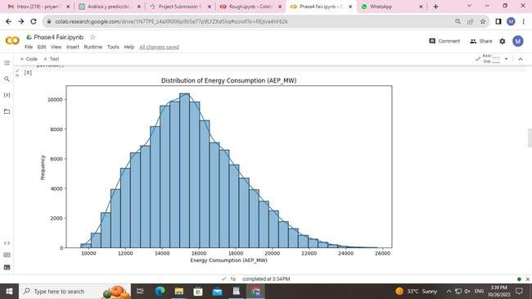

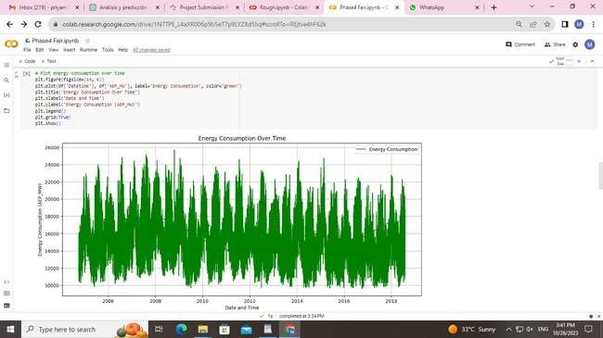

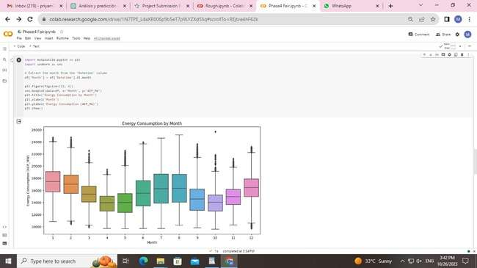

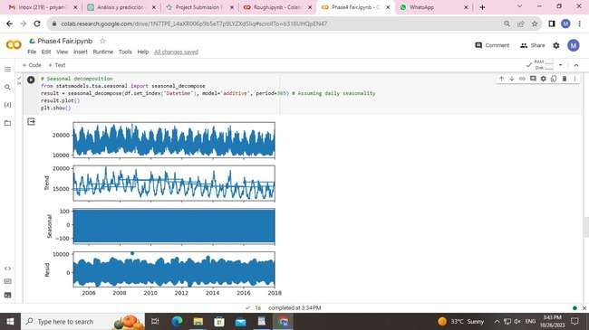

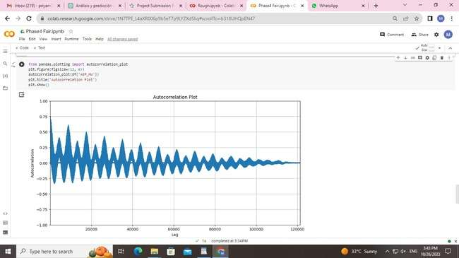

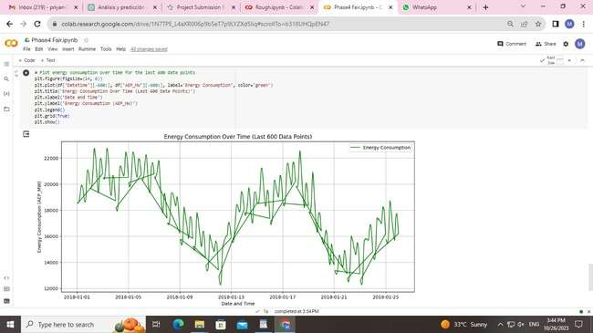

**Dataset Link:**

[**https://www.kaggle.com/datasets/robikscube/hourly-energy-consumption**](https://www.kaggle.com/datasets/robikscube/hourly-energy-consumption)

ADVANTAGE:

1. Define the Baseline: Start by establishing a baseline or reference point. This could be the existing system or technology you want to compare against.

2. Use Energy Meters: Install energy meters or data loggers to accurately measure the energy consumption of each system or device over a specific period of time. Ensure that the measurements are consistent and precise.

3. Collect Data: Record energy consumption data for the systems under consideration. Be sure to track data for the same duration and under similar operating conditions.

4. Calculate Energy Consumption: Calculate the total energy consumed by each system or device. This may involve converting measurements to a common unit (e.g., kilowatt-hours for electricity).

5. Analyze Results: Compare the energy consumption data and calculate the energy savings or advantage of one system over the other. This can be expressed as a percentage reduction in energy use or an absolute energy savings.

6. Consider Other Factors: Keep in mind that factors like initial cost, maintenance, and environmental impact should also be considered when determining the overall advantage.

7. Present Findings: Clearly communicate the results and advantages of the more energy-efficient system. This can help in decision-making and policy recommendations.

8. Repeat if Necessary: If conditions change or technology improves, it may be necessary to repeat the measurement and analysis to keep the data up to date.

DISADVANTAGE:

1. Define the Baseline: Establish a baseline by choosing the reference system or device that is more energy-efficient or consumes less energy.

2. Use Energy Meters: Install energy meters or data loggers to accurately measure the energy consumption of the system or device you want to evaluate.

3. Collect Data: Record energy consumption data for the system or device over a specific period, making sure the measurements are consistent and precise.

4. Calculate Energy Consumption: Calculate the total energy consumed by the system or device. Convert measurements to a common unit (e.g., kilowatt-hours for electricity).

5. Analyze Results: Compare the energy consumption data of the system or device you're evaluating to that of the more energy-efficient baseline. Calculate the additional energy used or disadvantage in terms of percentage increase or absolute energy wastage.

6. Consider Other Factors: As with measuring advantages, don't forget to consider other factors like initial cost, maintenance, and environmental impact when determining the overall disadvantage.

7. Present Findings: Clearly communicate the results and disadvantages of the less energy-efficient system or device. This can be essential for decision-making and improvements.

8. Identify Improvement Opportunities: After identifying the energy consumption disadvantage, look for ways to improve the system or device's efficiency. This may involve upgrading equipment, optimizing processes, or changing behaviors

BENEFITS:

1. Define Goals: Clearly define the energy consumption reduction goals. This could be reducing energy use by a certain percentage or achieving specific energy efficiency targets.

2. Establish a Baseline: Measure the initial energy consumption of the system, device, or process you want to improve. This serves as the baseline against which you'll measure benefits.

3. Implement Energy Efficiency Measures: Introduce energy-efficient technologies, practices, or processes that aim to reduce energy consumption.

4. Monitor and Measure: Continuously monitor and measure the energy consumption after implementing the efficiency measures. Use energy meters or data loggers to track usage accurately.

5. Analyze Data: Compare the post-improvement energy consumption data to the baseline data. Calculate the energy savings achieved in terms of percentage reduction or absolute energy reduction.

6. Calculate Cost Savings: Determine the cost savings associated with the reduced energy consumption. Calculate the financial benefits based on lower energy bills.

7. Consider Environmental Impact: Assess the environmental benefits, such as reduced greenhouse gas emissions and lower carbon footprint.

8. Evaluate Other Benefits: Take into account other advantages like improved equipment lifespan, reduced maintenance costs, and enhanced comfort or productivity in the case of buildings.

9. Present Findings: Clearly communicate the energy consumption benefits, including cost savings, environmental benefits, and any other positive outcomes.

10. Adjust and Optimize: Continuously monitor and make adjustments as needed to maintain or further enhance the energy consumption benefits.